LRH : Venkataraman *et al.*

RRH : Epizoochorous Seed Dispersal by Geladas

**Epizoochorous seed dispersal by an Afromontane savanna primate**

Vivek V. Venkataraman1,2, *, Carrie Miller2,3, Iris Foxfoot2, Bing Lin2,4, Zack L. Petrie2, Ruth A. Simberloff2, Odin Bernardo2, Nathan Redon2, Triana Hohn5, Jeffrey T. Kerby2,6, Nga Nguyen2,7, Peter J. Fashing2,7

1 Department of Anthropology and Archaeology, University of Calgary, Calgary, Canada

2 Guassa Gelada Research Project

3 Department of Anthropology, University of Minnesota

4 Princeton School of Public and International Affairs, Princeton University

5 Department of Biological Sciences, University of Calgary, Calgary, Canada

6 Aarhus Institute of Advanced Studies, Aarhus, Denmark

7 Department of Anthropology & Environmental Studies Program, California State University Fullerton

*To whom correspondence may be addressed: vivek.venkataraman@ucalgary.ca

Received: XXX ; revision accepted .

**ABSTRACT (255 words)**

Primates are prolific dispersers of seeds via endozoochory (i.e., defecation and spitting). In contrast, epizoochorous seed dispersal (i.e., via adhesion to fur) has rarely been observed in primates. On the Guassa Plateau in north-central Ethiopia, grass-eating gelada monkeys (*Theropithecus gelada*) regularly carry on their fur the barbed seeds of a commonly eaten plant, a low-lying herbaceous forb (*Agrocharis melanantha* [Apiaceae]). Here we describe the basic ecology of this plant-primate relationship. For 24 months (November 2017-December 2019), we monitored the number and location of *A. melanantha* seeds on the fur of geladas (*n* = 188 individuals) from four size classes: adult males, adult females, juveniles, and infants. Seed accumulation (*n* = 12,563 seeds in total) was seasonal and closely tracked patterns of landscape vegetation phenology at Guassa, peaking in September near the end of the rainy season. During seasonal periods of heavy seed accumulation, larger animals carried more seeds, with minor sex differences. Seeds accumulated most often on the hindlimbs and on the long-haired ‘cape’ (a secondary sexual characteristic) of adult males. Geladas almost never removed seeds during self- or social grooming. Rather, fine-scaled data on seed gain and loss from focal follows indicate that geladas gain and lose seeds every few minutes as they walk and sit in their stereotypically upright feeding positions amidst dense terrestrial vegetation. We estimate that, on average, geladas disperse seeds roughly 80 m from their parent plants. Geladas exert positive and negative fitness impacts on *A. melanantha* by regularly consuming its herbaceous and underground tissues and effectively dispersing its seeds.

**Key words**: primate; seed dispersal; epizoochory; gelada; Afroalpine; Ethiopia; *Theropithecus gelada*; *Agrocharis melanantha*

Seed dispersal plays a critical role in the dynamics of plant communities, ranging from population genetics and demography to ecosystem function and conservation (Howe and Smallwood, 1982). Among mammals, primates are prolific dispersers and predators of seeds, especially in forest habitats (Chapman 1995, Andresen et al. 2018). Documented cases of seed dispersal by primates typically involve endozoochory, in which animals spit or defecate out seeds (Chapman 1995). In contrast, research on epizoochorous seed dispersal, in which seeds adhere to an animal’s fur until they drop off, has heavily focused on ungulates (Albert et al. 2015, Baltzinger et al. 2019) but has rarely been addressed among primates (Chen et al. 2018). Given that epizoochorous seed dispersal in other animals primarily occurs among low-lying shrubs in open habitats (Sorenson 1986), one would expect several cercopithecine monkeys to disperse seeds via adhesion; for instance, baboons (*Papio* spp.), patas monkeys (*Erythorocebus patas*), and vervet monkeys (*Chlorocebus* spp.) are moderately-sized, terrestrial or semi-terrestrial, and feed omnivorously in savanna woodland habitats. However, despite decades of ecological research on these monkeys, we are not aware of any published reports of epizoochorous seed dispersal among them.

Here we describe a case of epizoochorous seed dispersal among another taxon of cercopithecines, gelada monkeys (*Theropithecus gelada*), which are endemic to the highlands of Ethiopia and unique among the primates in being largely confined to alpine grassland habitats (Bergman and Beehner 2013). We carried out our research on the Guassa Plateau (hereafter, Guassa), an ecologically intact tall-grass ecosystem in northern Ethiopia (Fashing et al. 2014, Welch et al. 2017). Geladas are exclusively terrestrial and forage mostly on graminoids and forbs in dense herds of several hundred individuals (Fig. 1A-B; Fashing et al. 2014; Jarvey et al. 2018). During fieldwork, we noticed that the fur of geladas was frequently adorned by small yellow-green seeds (Fig. 1C-H). The seeds derived exclusively from *Agrocharis melanantha* Hochst (family Apiaceae) (Fig. 1I-K), an herbaceous forb whose aboveground leaves and underground storage tissues are frequently consumed by geladas (Fashing et al. 2014). Could geladas be dispersing the seeds of one of their preferred foods via their fur?

Successful epizoochorous seed dispersal relies on emigration (the process of diaspores being loaded by an animal vector), transfer (the distance and time elapsed between attachment and detachment), and immigration (the subsequent ability of a loaded diaspore to become an adult plant) (Baltzinger et al. 2019). Such processes depend on factors such as seed and plant morphology, phenology, qualities of the nearby vegetation, and animal size, fur length, and behavior (Sorenson 1986, Baltzinger et al. 2019). This paper focuses on circumstances in which geladas accumulate and lose seeds on their fur (emigration and transfer phases).

*A. melanantha* is a low-lying annual or perennial shrub endemic to Africa which occurs widely across the continent up to the alpine belt around 4200 m asl (Hedberg et al. 2003). The fruits of *A. melanantha* are setose, oblong-ellipsoid in shape, and roughly 5 mm long (Hedberg et al. 2003). They arise from a compound umbel and have short, rigid, barbed styles (Hedberg et al. 2003). *Agrocharis* appears to be both wind- and animal-dispersed, as does the closely-related genus *Daucus*, which includes carrots (Lacey 1981, Lee and Downie 1999). To our knowledge, there are no published studies on the natural history of *A.* *melanantha*, however the herb is apparently used to treat the ‘evil eye’ among two traditional societies (Maale and Ari) in southern Ethiopia (Kidane et al. 2014).

Given that *A. melanantha* exhibits functional traits consistent with an animal dispersal syndrome, and that we have regularly observed these seeds on geladas, we sought to address five questions (with associated predictions) about the relationship between geladas and *A. melanantha* at Guassa.

Question 1. Where does *A. melanantha* occur at Guassa and what are its functional trait characteristics? We performed vegetation transects to survey the abundance of *A. melanantha* across different microhabitats at Guassa (short grass, roadside, shrub, or tall grass), in addition to mean plant height, vertical position relative to the surrounding canopy, number of fruits per umbel, and total number of seeds per plant. If *A. melanantha* is widely distributed across the landscape, then geladas are likely picking up and losing seeds regularly as they move across the landscape. On the other hand, if *A. melanantha* is patchily distributed and occurs only in particular microhabitats, then geladas may be accumulating seeds more sporadically, perhaps when approaching patches to feed.

Question 2. What is the seasonal pattern of seed accumulation of *A. melanantha* on the fur of geladas? We expected the phenology of *A. melanantha* to reflect the pronounced rainfall seasonality at Guassa (Fashing et al., 2014). In high-elevation tropical grasslands such as Guassa, rainfall seasonality tends to dictate the availability of grasses and herbs, and most plants time their growth and subsequent reproductive phenology to coincide with these periods of reduced water limitation (Fashing et al., 2014; Jarvey et al., 2018). Given the pronounced rainfall seasonality at Guassa occurs during the warmer summer months and the arid dry season occurs during colder months with frequent frosts (Fashing et al., 2014), we expect that there will be a clear seasonality in plant phenology across the landscape, and that *A. melanantha* will time its expensive tissue production (seeds) to coincide with this period of increased water availability and reduced likelihood of night-time frosts. Given that Guassa geladas generally forage in the same areas within the home-range across the year (VV Venkataraman, *pers. obs.*), the prevalence of seeds on gelada fur serves as a reasonable proxy for seed availability in the landscape.

Question 3. Do larger geladas, with higher absolute surface area, tend to carry more seeds of *A. melanantha*? Adult male geladas are roughly twice the body mass of adult females (M: 19 kg, F: 10 kg; Venkataraman et al., 2014). Juveniles and infants are substantially smaller, perhaps less than half the size of an adult female. While a larger surface area should result in the accumulation of more seeds, this may not be the case because juveniles feed on herbaceous vegetation more than adults at Guassa (Fashing et al 2014) and also run, jump, and play more, entailing more opportunities for adhesion.

Question 4. Which body region locations of geladas are most frequently adorned with seeds? We expected that the body regions that most frequently contact vegetation and those most conducive to adhesion (e.g., areas with layers of long hair) should bear the highest number of seeds. Geladas engage in a stereotypical sitting posture while feeding (Fig. 1B; Wrangham 1980), with the caudal part of the body (lower thorax and hindlimbs) regularly contacting vegetation. We also expect the long and flowing hair of the adult male ‘cape’, a secondary sexual characteristic (Fig. 1E-G), to accumulate many seeds.

Question 5. What are the circumstances under which seeds are acquired and lost? Grooming often results in barbed seed removal from fur among mammals (Sorenson 1986, Albert et al. 2015, Baltzinger et al. 2019). As prolific groomers (Iwamoto and Dunbar 1983), geladas are expected to remove seeds during self- and social grooming, in addition to regular habitual movement in their environment. We also estimated the flux of seed acquisition and loss at a fine timescale during focal follows to test the expectation that seeds are acquired in clumps then gradually lost. With these data we were also able to estimate how far geladas carry seeds.

**METHODS**

We conducted our study of geladas on the Guassa Plateau, a large (111 km2) an unusually intact Afroalpine tall-grass ecosystem located along the western edge of the Great Rift Valley (10°15’-10°27’ N; 39°45’-39°49’E) at elevations between 3200 and 3600 m asl (Fashing et al., 2014). Guassa consists of rolling hills, flat plateau areas, cliffs along its eastern border (on which the geladas sleep at night), and farms along its other borders, with one road bisecting the area. The large-mammal community at Guassa is intact and includes klipspringers (*Oreotragus oreotragus*), grey duikers (*Sylvicapra grimmia*), Ethiopian wolves (*Canis simensis*), African wolves (*Canis aureus lupaster*), spotted hyenas (*Crocuta crocuta*), servals (*Leptailurus serval*), and leopards (*Panthera pardus*) (Lin et al. 2020).

Over a recent 5-year period (2008-2013), the mean monthly temperature at Guassa was 11.0 ± 1.2 (SD) °C (Fashing et al., 2014). Mean monthly low and high temperatures were 4.3 ± 0.5 (SE) and 17.8 ± 0.3 (SE) °C, respectively. Annual mean rainfall was 1650 ± 243 (SD) mm (Fashing et al., 2014). Rainfall is strongly seasonal at Guassa, typically exhibiting a unimodal peak during July and August when more than two-thirds of the annual rainfall occurs. Rainfall drives the temporal variation in graminoid availability at Guassa, and Fashing et al. (2014) found cumulative rainfall three months prior to the end of each study month to be the best indicator of monthly food availability. We quantified the long-term annual phenology of landscape greenness using a LOESS curve fit to bi-weekly measures of the Normalized Difference Vegetation Index (NDVI) (Tucker 1979) – a proxy for vegetation greenness that correlates with above-ground productivity in low canopy environments (Pettorelli et al 2005, Pettorelli et al 2011). Using Google Earth Engine (Gorelick et al. 2017), we extracted the mean MOD13A1 v6 NDVI product (Didan 2015) from 2000-2021 across a core region of the focal herd’s range, and filtered the data to only include observations with the highest quality atmospheric conditions (i.e. QA score of 0, indicating no clouds, limited aerosols, etc). By including data from multiple decades we highlight the long-term nature of this seasonal green-up pattern, while also reducing the substantial impact of cloud artefacts on the satellite data at this site in any given year. The growth patterns identified correspond with the ‘wet season’ (July-October) and ‘dry season’ (November-June) rainfall thresholds used in Venkataraman et al. (2014).

Question 1 (Plant functional traits).- During September-October 2018 we conducted systematic surveys of *A. melanantha* across the main microhabitats (tall grass, short grass, shrub, or roadside) at Guassa by walking 20 randomly chosen non-overlapping 400 m transects within the home range of the gelada study band. During the transects, every 50 m we placed a 0.5 m x 0.5 m wooden square plot directly on the transect line. Within these plots we collected the following information: the number of *A. melanantha* plants and whether they were flowering, the absolute height of the plant from the ground and the height relative to the local canopy, the number of umbels on each plant, and the number of seeds on each umbel. We also noted microhabitat type. From these data, we calculated means and standard deviations on the abundance of *A. melanantha* plants across the Guassa landscape and their functional traits.

Question 2 (seed accumulation patterns on geladas).-We conducted our behavioral study between November 2017 and December 2019 and focused on the Steelers band of geladas at Guassa that has been investigated since December 2005 and followed on a near-daily basis since January 2007 (Nguyen et al. 2015). We collected data from a total of 232 individually recognized geladas during the 24 months. Seven trained observers (BL, CM, IF, RS, ZP, NR, and OB) counted *A. melanantha* seeds on the fur of geladas with the aid of binoculars prior or subsequent to focal behavioral follows that are regularly conducted as part of our long-term research protocol. Repeated sampling of the same individuals on the same day occasionally occurred, and in these cases the counts were averaged into a single daily observation for that individual. Observational conditions are generally excellent for geladas, with fieldworkers often able to stand as close as 1.5 m from focal individuals and to observe the animal from multiple angles. Counts were recorded when the observer was satisfied that all body regions had been clearly observed for long enough to enable accurate seed counts. This protocol minimizes the chance for bias in body region representation in the dataset. We also note that *A. melanantha* seeds are relatively uniform in appearance, and no seeds from other species that can be confused with *A. melanantha* were observed. Gelada fur does occasionally carry unidentifiable debris and seeds of *Rumex nepalensis* as well as *Rumex nervosus*. However, this is rare compared to the presence of *A. melanantha*. Moreover, confusion is unlikely because the seeds of *Rumex* sp. are red whereas the seeds of *A. melanantha* are green. Consequently, we are confident that there are virtually no errors of commission (items wrongfully identified as *A. melanantha*) in the dataset. To assess the annual pattern of seed dispersal, we plotted seed counts across time (every individual with a corresponding count of seeds on their fur on a given day), with the expectation of a unimodal curve centered around the wet season.

Question 3 (seed accumulation as a function of body size).- We surveyed four size classes of geladas: adult males, adult females, juveniles, and infants. The juvenile category includes small and medium juveniles of either sex. The infant category includes both brown (slightly older) and black (younger) infants of either sex. Both brown and black infants are considered unweaned and spend most of their time in close proximity or directly on the body of their mother. Large juveniles, regardless of sex, were assigned to the category ‘adult female’ because they are most similar in body size to adult females. Sub-adult males were assigned to the ‘adult male’ category because they appear most similar in size to adult males and have partially developed capes. Body size was treated as an ordered categorical variable in the analysis. To avoid confusion due to these mixed-sex classifications, we hereafter refer to these categories as large (adult and subadult males), medium (adult females and large juveniles), small (juveniles), and very small (infants). The mean number of observations on a monthly basis was highest in medium (194), followed by small (134), very small (81), and large (54).

To determine how time of year and body size are associated with seed accumulation through time, we compared several generalized linear mixed models using an information theoretic approach (Table 1). The dependent variable was seed counts, which was modeled with a Poisson distribution due to significant zero-inflation in the dataset (60% zeros). The global model included the variables month, year, and body size as fixed effects, and the individual identity of geladas was included as a random effect (nested within day of observation to account for repeat measurements). Month and year were treated as nominal categorical variables. The other models consisted of various combinations of the fixed effects. To compare model fit, we used the corrected Akaike information criterion (AICc) and calculated model weights (*wi*) (Anderson 2008). Lower AICc values indicate a better fit model to the data among the candidate set (Burnham and Anderson 2002; Burnham et al. 2010). To assess goodness of fit, we also calculated marginal R2 values. We used RStudio for data analysis (RStudio 2012),the package lme4 (Bates et al. 2015) for the mixed modeling portion of the analysis, AICcmodavg (Mazerolle 2013) to compute ΔAICc and Akaike weights for all candidate models, and MuMIn (Barton 2011) to estimate marginal R2 values.

Question 4 (distribution of seed accumulation across body regions).- We assigned seeds to several body region locations (Fig. 2). These included the face, head, upper back, mid-back, lower back, ventrum, cape (in the case of adult males), shoulder, upper arm/elbow, forearm, wrist/hand, flank, hip, thigh/knee, lower leg, ankle/foot, hindquarters, proximal tail, mid tail, and distal tail. Although the adult male cape overlaps with other body regions (e.g., shoulder, back, and flank), we coded it as a distinct body region because of its prominence (Fig. 1E-F). We distinguished between the cape and the nearest body location on the basis of proximity of the seed to the skin. When seeds were attached to the shorter hair closer to the skin, we coded these seeds by location rather than as belonging to the cape. Seeds coded as ‘cape’ were those on the outer, shaggy portion of the coat. Because we did not double count seeds, this coding scheme necessarily results in elevated counts for the cape and lower counts for other parts. To assess whether particular body regions accumulated more seeds, we restricted the analysis to the months of June-December when seeds were most abundant . For each day, we summed the number of seeds on a given body location across all individuals of a given size class, then averaged across months. We did not conduct statistical tests for this portion of the analysis.

Question 5 (context of attachment and detachment of seeds).-The circumstances of seed gain or loss were observed on an *ad libitum* all-occurrences basis. We provide anecdotal descriptions of the behavioral and/or ecological context of such events when possible. In addition, for 32 days between August and November 2019, the change in number of seeds attached to specific body regions of individuals was recorded during focal follows. During these focal follows, which ranged from seven to 21 minutes, an observer randomly chose a body region and conducted seed counts at intervals of approximately three minutes. In total, 489 focal follows were recorded. To compare the potential for contribution to seed dispersal of each body region, we calculated the mean rate of gain and loss for five different body regions (back, forearms, hindlimbs, cape, and ventrum). To obtain an estimate of how far geladas can carry seeds, we performed a basic calculation incorporating the mean rate of seed loss across all body regions and the mean speed and distance that geladas travel in a day at Guassa, which we report in the Discussion.

All analyses were performed in RStudio, version 1.0.153.

**RESULTS**

Question 1 (Plant functional traits).-*A. melanantha* plants were patchily distributed at Guassa: 75% (135/180) of plots on the transects had no *A. melanantha* plants, and those that did contained between two and eight individual plants. 87% (118/135) of individual *A. melanantha* plants encountered were in mixed short-grass habitats. Only 9% were found in tall-grass habitats. The remaining 4% occurred along the roadside or in shrub-dominated habitats. In October-November 2018 we closely examined 33 *A. melanantha* plants to characterize their functional traits. Mean plant height was 16.1 cm (min = 5 cm, max = 37 cm, SD = 7.1 cm), and mean height about the surrounding canopy was roughly 2.0 cm (min = -7.0 cm, max = 13.8 cm, SD = 4.8 cm). Plant traits of *A. melanantha* differed between short- and tall-grass habitats. In tall-grass habitat, *A. melanantha* exhibited a mean of 25.7 cm (SD = 5.8, n = 32) in height. The plant was shorter in short-grass habitat, with a mean of 6.5 cm (SD = 4.4 cm, n = 25)*.* *A. melanantha* had a mean of 5.4 fruits per umbel (n = 153 umbels; min = 1, max = 16, SD = 2.9) and 25 seeds per plant (min = 1, max = 95, SD = 24).

Question 2 (seed accumulation patterns on geladas).-We counted a total of 12,563 *A. melanantha* seeds attached to gelada (*n* = 232 individuals) fur over the course of the study. The prevalence of seeds on the geladas was highly seasonal and mirrored patterns of landscape phenology driven by rainfall at Guassa (Fig. 3ab). Seeds were most abundant on the fur of geladas during the end of the wet season in late September, when hundreds of seeds were routinely observed on individuals (Fig. S2). In one extraordinary case, we counted 511 seeds on an adult female (note: in this particular case, the observer counted one body region and extrapolated to the rest of the body to avoid double-counting; thus, the precision of this number should be treated with caution). Between January and May, few seeds were observed (Fig 3b).

Question 3 (seed accumulation as a function of body size).-The mean number of *A. melanantha* seeds attached to each size class of geladas during the months of July-November, when *A. melanantha* seeds were most available, generally followed our expectations on the role of body size (Fig. 4). The magnitude of the estimates for the fixed effect of body size (Table 2) show an increase of ~1.4x seeds with each increase across body size class.

The best-ranking model predicting seed counts was the global model. The AICc weight was 1, indicating that this model was the most predictive model among the candidate set (Table 1). As indicated by the marginal R2 values for our models, the global model (model 1) accounted for 64% of the variance in the data set (Table 1). According to the output of this model (Table 2), each increase in body size class was associated with ~1.4 times the number of seeds. These differences are relatively modest, though they appear to be driven by the high prevalence of zeros in the dataset. While these numbers may seem low, Figure 4 shows that during the month of September, juvenile and adult monkeys carried almost 20 seeds on a daily basis. Taken together, these results show that time of year and body size are good predictors of seed counts. However, as indicated from the model output pertaining to the random effect of individual ID (nested within day of observation), the among-individual standard deviation was moderate in magnitude (~1.4) and similar to the magnitude of the regression coefficients for the fixed effects of body size (also ~1.4), but lower than that of month during the wet season (~ 5). These results suggest high variability in seed accumulation between individuals and days.

Question 4 (distribution of seed accumulation across body regions).-*A. melanantha* seeds were distributed across multiple body regions in each size class of geladas (Fig. 5). The male cape attracted more seeds on average than any other body region, however we note that this result stems in part from our sampling methodology (see Methods). In some cases, we observed that seeds buried in the cape remained for long periods of time (e.g. upwards of a week). Following the cape, males accumulated the most seeds on their lower back, followed by the thigh and knee and lower legs. Adult females carried more seeds on their lower legs than on their thighs and knees. Juveniles accumulated seeds primarily on their thighs, knees, and lower legs.

Question 5 (context of attachment and detachment of seeds).- We observed the context of seed acquisition or removal in 19 instances (Table 3). Instances of acquisition occurred when walking, sitting, or playing on *A. melanantha* patches. In one set of cases, two adult females removed seeds on their arms and ate them. There were also cases in which infants removed seeds from their fur and test-bit them before rejecting them. We observed only one case of seeds being removed during grooming. Some seeds were observed to fall off when geladas walked or ran through the grass. Single instances of acquisition and loss could involve five or more seeds, suggesting that seeds can be gained or lost relatively rapidly. Seeds were observed to be gained in clumps irregularly while seeds were observed to be lost in a more gradual pattern (Fig. 6). There was a gain of seeds during only 6.8% of the focal follow intervals in which a gain of seed could have possibly been observed. In contrast, seed loss was observed during 14% of the focal follow intervals in which a loss of seeds was possible (i.e. seeds were present to be lost). For a clump of a given size, seeds were more frequently gained than lost. For example, 68% of instances of seed acquisition involved clumps of more than one seed while 55% of instances of seed loss involved clumps of more than one seed. The maximum clump size lost at a given time was 12 seeds while the maximum clump size gained at one time was 28 seeds. The cape region had the fastest mean rate of gain (1 seed every 5 minutes 6 seconds) but a slow rate of loss (1 seed every 27 minute 35 seconds) in comparison to rates of gain and loss observed in the other body region locations (Table 4). The ventrum had substantially lower rates of both gain and loss than the other body regions (Table 4).

**DISCUSSION**

Data from Guassa indicate that the functional traits of *A. melanantha* are consistent with an animal-based dispersal syndrome. The plants vary in height according to microhabitat but are generally low-lying and extend just above the canopy among dense vegetation where the barbed seeds are likely to be picked up by passing animals. Indeed, most *A. melanantha* plants were found in the short grass habitat that geladas prefer to feed in—and where they spend more time shuffling—relative to other habitats (Eriksen 2017). While *A. melanantha* is patchily distributed (occurring in only 25% of plots), patches often contain numerous plants (up to eight), and individual plants often hold many seeds (up to 95). When geladas encounter patches of A*. melanantha* during travel or feeding, many seeds can be accumulated at once. The phenology of *A. melanantha*, as reflected in trends of geladas carrying seeds, appears to be highly seasonal, as expected based on the strong rainfall and landscape greenness seasonality at Guassa. Our statistical models demonstrate that, in accordance with expectations, both time of year and body size were good predictors of seed counts on geladas (Tables 1-2, Fig. 3).

Adult geladas carried more seeds than infants and juveniles, and adult males carried marginally more seeds than adult females (Table 2). As expected, the male cape does indeed attract many seeds (Fig. 5), but overall differences between males and females were minor. Several behavioral factors may reduce the differences between size classes in the number of seeds carried. For instance, infants are almost always in contact with their mothers and likely to acquire seeds via physical contact (Fig 1C-D). Juveniles also frequently play and roll around in vegetation, which may result in a high degree of flux in seed acquisition and loss. These are examples of secondary external dispersal.

Other than the capes of adult males, which carried prodigious numbers of *A. melanantha* seeds, geladas of all size classes tended to collect seeds mostly on their legs and hindparts (Fig. 4). These results are consistent with the upright feeding posture of geladas as driving the accumulation of seeds in the fur of the hindparts of the animals. Our *ad libitum* observations, while necessarily rare, indicate that *A. melanantha* seeds are inadvertently acquired and lost by geladas, and that little attention is paid to their removal. Overall, these patterns suggest that geladas incidentally accumulate *A. melanantha* seeds as they move across the landscape and habitually feed while sitting on their haunches.

In studies of epizoochorous dispersal, acquisition of seeds is often considered to be inadvertent and random on the part of the animal (Sorenson 1986). While geladas will encounter *A. melanantha* randomly as they travel, presumably they are also actively drawn to these patches because *A. melanantha* is a highly desired food item. Edible forbs, including *A. melanantha* which is among the most commonly consumed by geladas, represent < 7% of land cover at Guassa yet comprise almost 30% of the geladas’ diet, suggesting a high level of selectivity for *A. melanantha* and other forbs (Fashing et al. 2014). This focus on forbs is likely due to their high levels of calories and protein, and low levels of fiber and toxins (PJ Fashing, *unpublished data*). High selectivity at the landscape level may also be suggested by the current study, in which we found that *A. melanantha* did not occur in 75% of surveyed plots. Juveniles disproportionately consume forbs (including *A. melanantha*) whereas larger animals cannot afford to be as selective and instead focus on the more widely available graminoids at Guassa (Fashing et al. 2014). During the dry season (December-May), when geladas shift their diet to include more underground foods, the roots of *A. melanantha* are heavily exploited, primarily by larger individuals because they are difficult to extract, and the tissue is mechanically challenging to process (Venkataraman et al. 2014 ; Fig S1). As noted above, *A. melanantha* does not produce fruit during this period. Data on how frequently geladas encounter *A. melanantha* patches and forage within them are needed to further explore these ideas.

We argue that geladas are likely to be the most effective animal dispersers of *A. melanantha* at Guassa, and more generally in the Ethiopian highlands. Other mammals are present at Guassa, and elsewhere in high-altitude Ethiopia, including carnivores (hyenas, leopards, servals, Ethiopian wolves, African wolves, mustelids), ungulates (duikers and klipspringers), rodents (six species of rats and mice), Abyssinian hares (*Lepus habessinicus*), rock hyraxes (*Procavia capensis*), Egyptian mongoose (*Herpestes ichneumon*), and zorillas (*Ictonyx striatus*). Yet, in Afroalpine habitats in Ethiopia, geladas have at least five times the biomass of other wild large mammals such as klipspringer (*Oreotragus oreotragus*), ibex (*Capra walie*), and bushbuck (*Tragelaphus sylvaticus*) (Dunbar 1978). Geladas also form some of the largest aggregations of any primate (up to ~800 individuals in herds at Guassa) and the herds move relatively cohesively through the landscape (Figure 1B). It is currently unknown whether and to what extent other Guassa mammals consume and/or disperse *A. melanantha*. Although rodents are probably too small to detach umbels from the peduncles of *A. melanantha* as geladas do, given their large biomass at Guassa, it would be worth investigating whether rodents disperse *A. melanantha* via endozoochory and/or epizoochory. Similar considerations apply to domestic livestock common in the Ethiopian highlands such as sheep, goats, donkeys, horses, and cows.

The effectiveness of *A. melanantha* dispersal via gelada fur relies not only on the emigration and transfer phases detailed in this paper, but also on the immigration phase in which seeds fall to the ground and begin the process of growing into a new plant. At present we do not know how long *A. melanantha* seeds are retained on gelada fur because we were not able to track the acquisition and loss of individual seeds. There are hints, however, that large numbers of seeds may be acquired and lost relatively quickly (within hours or days), as has been found among ungulates (Bullock et al. 2011, Liehrmann et al. 2018). Given that *A. melanantha* plants often have up to 25 seeds available during the peak season, we had expected a pattern of steep gains followed by a shallow decrease as the monkey moved through the habitat. As expected, we found that seeds are usually gained sporadically in larger clumps and lost gradually. Again, data on how frequently geladas encounter and forage within *A. melanantha* patches and the change in seed counts during these times could potentially help elucidate a more accurate rate of seed gain.

The variation in time of seed gain and loss reported for the five observed body regions further indicates that some body regions are more involved in epizoochorous seed dispersal than others. Although the male cape does gain seeds the quickest, its relatively low loss rate indicates that any seeds gained by the cape are typically accumulated. This pattern of accumulation complements the high number of seeds observed on the cape throughout the entirety of this study (Fig. 3). In contrast, the hindlimbs, forearms, and the back evinced more dynamic seed fluxes. This is in line with the observations that these body regions are in close proximity to plants while geladas are moving and feeding. Seeds were rarely gained or lost by the ventrum, which does not regularly contact vegetation with the full weight of the individual, as does the hindlimb.

To estimate how far geladas might be dispersing seeds, we combined basic estimates of the mean distance geladas travel with our findings on the time it takes for a seed to be lost from a gelada’s fur. The daily path length of the gelada study band at Guassa is ~3.5 km, the annual home range is ~9 km2, and the sleeping cliff site changes every few days (Moua 2015). Over several years of data collection, it has been found that the study band at Guassa is active for approximately ten hours throughout the day (PJ Fashing, *unpublished data*). From these values of day range and day length, we calculated that geladas move with a mean speed of 0.35km/hr. Assuming one seed is lost approximately every 13 minutes 32 seconds (Table 4), we estimated that geladas have the potential to disperse seeds roughly 80 m from their parent plant. These estimates suggest that seeds adhered to geladas have the potential to travel far from the parent plant. In fact, we observed some desiccated seeds remaining on geladas for months beyond the time when *A. melanantha* is available in the environment. It remains an open question for how long *A. melanantha* seeds remain viable.

Other species in the Apiaceae family of similar or greater height than *A. melanantha* have been found to have seeds dispersed by wind up to a maximum of 14 m (Jongejans and Telenius 2001). Seeds from taller plants and those which have adaptations associated with dispersal via wind (e.g., wings) typically are dispersed farther (Jongejans and Telenius 2001). *A. melanantha* is considered a low-lying plant and its seeds lack adaptations for wind dispersal. Therefore, it seems safe to say that *A. melanantha* seeds travel farther when attached to a gelada than by wind or by merely falling with a dying parent plant (barochory; Baltzinger et al. 2019).

Geladas not only carry seeds of *A. melanantha* on their fur, but also consume its foliage, seeds, and underground storage organs (Fashing et al. 2014). We suspect that geladas may also be endozoochorously dispersing *A. melanantha*. Much like wild pigs that disperse seeds epizoochorously via their fur and consume the seeds of those same plants (Baltzinger et al. 2019), geladas may also be exerting conflicting fitness impacts on *A. melanantha*. If so, this may be occurring in a seasonal context at Guassa. There are stark differences in vegetation quality between the wet and dry season. Vegetation becomes brown and desiccated during the dry season (Fashing et al. 2014). Yet because of the relatively intact and tall-grass canopy, there is much shade in which herbs can remain green and edible. During this time the geladas tend to eat herbs shaded by the tall *Festuca* canopy, including the aboveground and belowground parts of *A. melanantha* (Fashing et al. 2014). Thus geladas are primarily predators of *A. melanantha*, particularly during the dry season. Yet, as the present study shows, they help to disperse the plant during several months of the year. To better understand the fitness impact that geladas have on *A. melanantha*, it would be particularly valuable to explore whether seeds pass to the gut without being crushed by the molars. It is telling that geladas purposely seek out individual seeds of *A. melanantha* on the umbels, rather than accidentally consuming them. This suggests that the seeds are targeted as food items and perhaps more likely to be chewed prior to passing to the gut. It would be useful to know whether geladas’ feces contain intact and viable (i.e. unchewed) *A. melanantha* seeds, and how this process influences seed viability.

Sorenson (1986) argued that epizoochorous dispersal is more successful if animals are unaware of the seeds, as animals may remove them during grooming. Given that geladas do consume *A. melanantha* seeds, their behavior toward the seeds of *A. melanantha* on the fur is puzzling. In only one instance have we observed geladas removing seeds while engaging in social grooming. In only two instances did we observe seed removal during self-grooming, suggesting the seeds cause no discomfort. Given that grooming is carefully observed during focal follows and not likely to be missed, the absence of seed removal during self- or social grooming is particularly notable. Perhaps the seeds are not worth the time investment to remove, as geladas are highly time-constrained (Dunbar 1992). Geladas cannot fail to be aware of the seeds, which are clearly visible. The ambivalence shown toward seeds on the fur could result from the seeds not being recognized as such or being unappetizing due to desiccation or rot, though this possibility may be unlikely given that the seeds often looked identical to the ones still on the plants. On the other hand, the idea is supported by the fact that it was usually gelada infants who were observed test-biting the seeds, and they were generally rejected (Table 3), whereas adults were not seen performing test bites of *A. melanantha* seeds plucked from their fur. It is also possible that seed removal during grooming is not attempted because the seeds tend to be deeply entangled in clumps and may cause painful hair-pulling (potentially leading to an agonistic interaction) and/or does not result in the hand-to-skin contact that appears to characterize effective social grooming. Another possibility is that individual burrs provide fewer calories and/or nutrients than the insects and scabs the geladas usually pick off each other’s bodies. Overall, these puzzling observations contrast with the more purposeful seed removal behavior observed among ungulates (Sorenson 1986).

A defining aspect of epizoochorously dispersed fruits is that there is no reward for dispersal (Sorenson 1986). Janzen’s (1984) ‘foliage is the fruit’ hypothesis argued that selection has shaped some plants to attract large herbivores to eat their leaves and incidentally ingest, then disperse, their seeds. Couvreur et al. (2005) used observations of donkey feeding behavior and seed dispersal to argue that epizoochory and endozoochory may exist in a single system and be complementary. We may be observing a similar phenomenon with *A. melanantha* and geladas because numerous parts of the plant are consumed and attractive to geladas, epizoochory seems to be clearly occurring, and endozoochory remains plausible. We suspect that *A. melanantha*, which has a cosmopolitan distribution across Africa (Lee and Downie 1999), has been shaped by evolution to appeal to large mammals—or at least to attach to them. Our study suggests that, in the Ethiopian highlands, it seems to be geladas in particular that help *A. melanantha* to flourish. Further information on the dispersal ecology of *A. melanantha* is necessary to explore co-evolution between this plant and mammal communities.

Here we have described a case of epizoochorous seed dispersal in a grassland primate. Geladas appear to regularly and effectively transport the seeds of a frequently consumed herbaceous forb, *A. melanantha*, in their fur in large quantities, and they do not appear to actively remove the seeds during self- or social grooming. These circumstances contrast with the only other description of epizoochorous seed dispersal in a primate (Chen et al. 2018), in which free-ranging golden snub-nosed monkeys (*Rhinopithecus roxellana*) in the temperate forests of central China carried haired, hooked, or awned seeds on their fur derived primarily from three herbaceous plants (*Geum aleppicum*, *Torilis japonica*, and *Agrimonia pilosa*) which they do not consume (Zuofo Xiang, *pers. Comm.*). The relationship between geladas and *A. melanantha* seems distinctive in the extent to which geladas rely on *A. melanantha* as a food source and potentially exert both positive and negative fitness impacts on a single plant species. While much remains to be discovered in this system, we hope that the results presented here will help bring to light more instances of epizoochorous seed dispersal in primates and add to our understanding of how primates contribute to ecosystem function.

**ACKNOWLEDGMENTS**

The authors thank the Ethiopian Wildlife Conservation Authority, Amhara Regional government, and Mehal Meda Woreda for permission to conduct this research, which was noninvasive and adhered to the legal requirements of Ethiopia. We thank Dean Gibson and San Diego Zoo, California State University Fullerton, Primate Conservation Inc., Gisela and Norman Fashing, Joseph and Patricia Healey, Anita and Hans-Peter Profunser, and the many contributors to the Christopher Schroen Memorial Fund for their financial support of the long-term gelada research at Guassa. Metikay Basasen, Badiloo Muluyee, Shoafera Tessema, Bantilka Tessema, and Tasso Wudimagegn provided crucial logistical support in the field.

**DATA AVAILABILITY STATEMENT**

The data used in this study, along with computer code to replicate the data analyses, will be archived at the first author’s website (vivekvenkataraman.com).

**LITERATURE CITED**

Albert, A., Auffret, A.G., Cosyns, E., Cousins, S.A., D’hondt, B., Eichberg, C., Eycott, A.E., Heinken, T., Hoffmann, M., Jaroszewicz, B. and Malo, J.E. 2015. Seed dispersal by ungulates as an ecological filter: a trait‐based meta‐analysis. Oikos 124:1109-1120.

Anderson, D.R., 2008. Model based inference in the life sciences: a primer on evidence. Springer, New York.

Andresen, E., Arroyo-Rodriguez, V., and Ramos-Robles, M.. 2018. Primate seed dispersal: old and new challenges. International Journal of Primatology 1:1-23.

Baltzinger, C., Karimi, S., and Shukla, U. 2019. Plants on the move: hitch-hiking with ungulates distributes diaspores across landscapes. Frontiers in Ecology and Evolution 7:38. Doi: 10.3389/fevo.2019.00038.

Barton, K., 2011. MuMIn: multi-model inference. The R Project for Statistical Computing, Vienna, Austria.

Bates, D., M. Machler, B. Bolker, and Walker, S. 2015. Fitting linear mixed-effects models using lme4. Journal of Statistical Software 67:1-48.

Bergman, T. J., and Beehner, J. C. 2013. *Theropithecus gelada* Gelada (Gelada Baboon). In Mammals of Africa: Volume II: Primates (eds T. Butynski, J. Kingdon and J. Kalina), pp. 240–244. Bloomsbury Publishing, London.

Bullock, J.M., Galsworthy, S.J., Manzano, P., Poschlod, P., Eichberg, C., Walker, K. and Wichmann, M.C., 2011. Process‐based functions for seed retention on animals: a test of improved descriptions of dispersal using multiple data sets. Oikos 120 :1201-1208.

Burnham, K.P., and Anderson, D.R., 2002. Model selection and multi-model inference: a practical information-theoretic approach. Springer, New York.

Burnham, K.P., Anderson, D.R., and Huyvaert, K.P., 2010. AIC model selection and multimodel inference in behavioral ecology: some background, observations, and comparisons. Behavioral Ecology and Sociobiology 65:23-35.

Chapman, C.A., 1995. Primate seed dispersal: coevolution and conservation implications. Evolutionary Anthropology 4:74-82.

Chen, Y., Chen, H., Zhang, Y., Yao, H., Yang, W., Zhao, Y., Ruan, X. and Xiang, Z., 2018. First evidence of epizoochorous seed dispersal by golden snub-nosed monkeys (*Rhinopithecus roxellana*) in temperate forest. Plant Ecology 219:417-427.

Couvreur, M., Cosyns, E., Hermy, M. and M. Hoffmann. 2005. Complementarity of epi‐and endozoochory of plant seeds by free ranging donkeys. Ecography 28:37-48.

Dunbar, R.I.M. 1978. Competition and niche separation in a high-altitude herbivore community in Ethiopia. African Journal of Ecology 16:183-199.

Dunbar, R.I. 1992. Time: a hidden constraint on the behavioural ecology of baboons. Behavioral Ecology and Sociobiology 31:35-49.

Eriksen, G.A., 2017. Foraging strategies of wild gelada monkeys (*Theropithecus gelada*) in an Afroalpine grassland at Guassa, Ethiopia. MSc Thesis, University of Oslo.

Fashing, P.J., Nguyen, N., Venkataraman, V.V. and J.T. Kerby. 2014. Gelada feeding ecology in an intact ecosystem at Guassa, Ethiopia: variability over time and implications for theropith and hominin dietary evolution. American Journal of Physical Anthropology 155:1-16.

Hedberg, I., Edwards, S. and S. Nemomissa. 2003. Flora of Ethiopia and Eritrea. Vol. 4. Part 1, Apiaceae to Dipsacaceae. National Herbarium, Addis Ababa University.

Howe, H.F. and J. Smallwood. 1982. Ecology of seed dispersal. Annual Review of Ecology and Systematics 13:201-228.

Iwamoto, T. and Dunbar, R.I.M., 1983. Thermoregulation, habitat quality and the behavioural ecology of gelada baboons. Journal of Animal Ecology 52:357-366.

Janzen, D.H., 1984. Dispersal of small seeds by big herbivores: foliage is the fruit. The American Naturalist 123:338-353.

Jarvey, J.C., Low, B.S., Pappano, D.J., Bergman, T.J. and Beehner, J.C., 2018. Graminivory and fallback foods: annual diet profile of geladas (*Theropithecus gelada*) living in the Simien Mountains National Park, Ethiopia. International Journal of Primatology 39:105-126.

Jongejans, E. and Telenius, A., 2001. Field experiments on seed dispersal by wind in ten umbelliferous species (Apiaceae). Plant Ecology 152:67-78.

Kidane, B., van Andel, T., van der Maesen, L.J.G. and Asfaw, Z., 2014. Use and management of traditional medicinal plants by Maale and Ari ethnic communities in southern Ethiopia. Journal of Ethnobiology and Ethnomedicine 10:46.

Lacey, E.P., 1981. Seed dispersal in wild carrot (*Daucus carota*). The Michigan Botanist 20:15-20.

Lee, B.Y. and Downie, S.R., 1999. A molecular phylogeny of Apiaceae tribe Caucalideae and related taxa: inferences based on ITS sequence data. Systematic Botany 24:461-479.

Liehrmann, O., Jégoux, F., Guilbert, M.-A., Isselin-Nondedeu, F., Saïd, S., Locatelli, Y., et al. 2018. Epizoochorous dispersal by ungulates depends on fur, grooming and social interactions. Ecology and Evolution 8:1582-1594. Doi: 10.1002/ece3.3768.

Lin, B., Foxfoot, I.R., Miller, C.M. Venkataraman, V.V., Kerby, J.T., Bechtold, E.K., Kellogg, B.S., Nguyen, N., Fashing, P.J., 2020. Leopard predation on gelada monkeys at Guassa, Ethiopia. American Journal of Primatology 82: e23098.

Mazerolle, M.J., 2013. Package ‘AICcmodavg’. The R Project for Statistical Computing, Vienna, Austria.

Moua, C., 2015. Long-term ranging patterns of wild gelada monkeys (*Theropithecus gelada*) on an intact afro-alpine grassland at Guassa, Ethiopia (MSc, California State University, Fullerton).

Nguyen, N., Fashing, P. J., Boyd, D. A., Barry, T. S., Burke, R. J., Goodale, C. B., Jones, S.C.Z., Kerby, J.T., Kellogg, B.S., Lee, L.M., Miller, C.M., Nurmi, N.O., Ramsay, M.S., Reynolds, J.D., Stewart, K.M., Turner, T.J., Venkataraman, V.V., Knauf, Y., Roos, C., Knauf, S., 2015. Fitness impacts of tapeworm parasitism on wild gelada monkeys at Guassa, Ethiopia. American Journal of Primatology 77: 579-594.

|  |
| --- |
|  |
|  |

Sorensen, A.E., 1986. Seed dispersal by adhesion. Annual Review of Ecology and Systematics 17:443-463.

Venkataraman, V.V., Glowacka, H., Fritz, J., Clauss, M., Seyoum, C., Nguyen, N. and Fashing, P.J., 2014. Effects of dietary fracture toughness and dental wear on chewing efficiency in geladas (*Theropithecus gelada*). American Journal of Physical Anthropology 155:17-32.

Welch, C., Frost, T.B. and Kerby, J.T., 2017. Where the World’s Only Grass-Eating Monkeys Thrive. National Geographic.

Wrangham, R.W., 1980. Bipedal locomotion as a feeding adaptation in gelada baboons, and its implications for Hominid evolution. Journal of Human Evolution 9 :329-331.

**TABLES**

TABLE 1. Results of generalized linear mixed model selection procedure (K = number of estimated parameters; LogL = log-likelihood; wi = Akaike weights; R2 = marginal R2 values) predicting the number of *A. melanantha* seeds attached to geladas. The individual identity of geladas, nested in month, was included as a random effect in all models.

|  |  |  |  |  |  |  |
| --- | --- | --- | --- | --- | --- | --- |
| **Fixed effects** | **K** | **AICc** | **ΔAICc** | **wi** | **LogL** | **R2** |
| AgeSex + Year + Month | 16 | 23799.27 | -- | 1 | -11883.58 | 0.64 |
| Year + Month | 13 | 24022.28 | 223.0098 | 0 | - 11998.10 | 0.58 |
| AgeSex + Month | 14 | 24085.69 | 286.4168 | 0 | - 12028.80 | 0.62 |
| Month | 11 | 24273.12 | 473.8444 | 0 | - 12125.53 | 0.57 |
| AgeSex + Year | 7 | 24520.38 | 721.1054 | 0 | - 12253.18 | 0.07 |
| Year | 4 | 24679.32 | 880.0458 | 0 | - 12335.65 | 0.007 |
| AgeSex | 5 | 24769.35 | 970.0801 | 0 | - 12379.67 | 0.04 |
| None (random intercept only) | 2 | 24896.36 | 1097.0916 |  | -12446.18 | 0 |

TABLE 2. Model output for the best-fitting model (the global model in Table X). Gelada individual ID nested within month was included as a random effect. Model estimates b and standard errors SE as well as test statistic *Z-* and *P*-values are given for fixed effects. January and 2017 were reference levels for the fixed effects of month and year, respectively.

|  |  |  |  |  |
| --- | --- | --- | --- | --- |
| **Fixed Effect** | **b** | **SE** | ***Z*-value** | ***P*-value** |
| Intercept | -3.8819 | 0.60839 | -6.381 | **<0.005** |
| AgeSex | 1.3506 | 0.11026 | 12.249 | **<0.005** |
| Year  2017  2018  2019 | -0.3593 -0.7791 | 0.05673 0.06048 | -6.334  12.881 | **<0.005**  **<0.005** |
| Month  January  February  May  June  July  August  September  October  November  December | -0.7111 -1.0382 2.4621 3.9263 4.0042 5.4699  5.0932 4.2227 2.7889 | 0.7899 0.8144 0.6313 0.6217 0.6223 0.6203 0.6171 0.6171 0.6266 | -0.900  -1.275  3.900  6.315  6.434  8.818  8.254  6.843  4.451 | 0.37  0.20  **<0.05**  **<0.005**  **<0.005**  **<0.005**  **<0.005**  **<0.005**  **<0.005** |

TABLE 3. Descriptions of opportunistic observations of *A. melanantha* seeds being acquired or lost on gelada fur.

|  |  |  |  |  |  |  |
| --- | --- | --- | --- | --- | --- | --- |
| **Event** | **Sex** | **Size Class** | **Acquisition / Loss** | **Quantity** | **Body Location** | **Notes** |
| 1 | M | Small Juvenile | A | 4 | Hindquarters | Sat on flower |
| 2 | M | Small Juvenile | A | 3 | 2 Thigh; 1 Hindquarters | Sat on flower |
| 3 | M | Medium Juvenile | A | 8 | Hindquarters | Sat on flower |
| 4 | F | Small Juvenile | A | 2 | Forearm | Feeding |
| 5 | M | Brown Infant | A | 5 | 3 Thigh; 2 Lower leg | Sat on flower |
| 6 | M | Large Juvenile | A | 6 | Ventrum | Entire umbel attached to stomach during feeding |
| 7 | F | Small Juvenile | A | 5 | Thigh | Entire umbel attached to thigh after sitting on plant |
| 8 | F | Brown Infant | A | 4 | 1 Foot; 1 Lower leg; 1 Mid-tail; 1 Thigh | Playing |
| 9 | F | Adult | A | 2 | Lower leg | Walking |
| 10 | M | Adult | A | 1 | Thigh | Walking |
| 11 | F | Brown Infant | L | 1 | Thigh | Running |
| 12 | F | Small Juvenile | L | 2 | Forearm | Removed and eaten |
| 13 | F | Black Infant | L | 1 | Upper arm | Removed and eaten |
| 14 | F | Adult | L | 1 | Hindquarters | Removed by individual A while grooming B; attempted to eat but interrupted by individual C; transferred to C’s arm |
| 15 | F | Brown Infant | L | 1 | Lower leg | Removed from fur, inspected, eaten, then spit out |
| 16 | F | Adult | L | 5 | Hindquarters | Sat on plant and acquired entire umbel |
| 17 | F | Adult | L | 1 | Proximal tail | Walking |

TABLE 4. Mean rate of seed gain and loss by body region.

|  |  |  |
| --- | --- | --- |
| **Body Region** | **Time to gain one seeda** | **Time to lose one seedb** |
| **Cape** | 5 min 6 sec[remove seconds] | 27 min 35 sec |
| **Hindlimbs** | 7 min 15 sec | 10 min 33 sec |
| **Forearms** | 20 min 30 sec | 6 min 52 sec |
| **Back** | 29 min 59 sec | 22 min 51 sec |
| **Ventrum** | 1 hr 53 min 17 sec | 44 min 32 sec |
| **All Regions** | 14 min 14 sec | 13 min 32 sec |

aSample size for gains includes only intervals where there could have been an observed gain of seeds (i.e., it was not the first interval of the focal), *n*=2169.

bSample size for losses includes only intervals where there could have been an observed loss of seeds (i.e., there was a non-zero number of seeds in the preceding interval and it was not the first interval of the focal), *n*=555.

**FIGURE LEGENDS**

FIGURE 1.(A) An aggregation of gelada monkeys at Guassa containing adult males (larger, with prominent cape and white hair around the red chest patch) and females. Note that adult males are nearly twice the size of adult females. Photo by Vivek V. Venkataraman (B) Geladas foraging on graminoids and forbs in dense herds at Guassa. Photo by Vivek V. Venkataraman (C) Two adult females grooming. Note numerous *A. melanantha* seeds on the right individual’s leg and thorax. Photo by Jeffrey Kerby. (D)Adult female walking with infant on back. Numerous seeds are visible. Photo by Vivek V. Venkataraman (E-F) Adult males with dozens of seeds in their capes. Photos by Vivek V. Venkataraman (G)*A. melanantha* seeds attached to the cape of an adult male and being ignored by a female groomer. Photo by Jeffrey Kerby(H) Close-up view of *A. melanantha* seeds adhering to gelada fur. Photo by Jeffrey Kerby. (I) *Agrocharis melanantha* in the tall-grass ecosystem of Guassa, Ethiopia. Photo by Peter J. Fashing (J) The seeds of *A. melanantha* with reddish flowers. Photo by Zack Petrie. (K) *A. melanantha* exhibits several fruits per umbel and has short styles on the schizocarp (adult male fingers for scale). Photo by Zack Petrie.

FIGURE 2. Schematic representation of female (left) and male (right) gelada monkeys with labeled body region locations. Illustrations by Samantha Shields.

FIGURE 3.Seasonal variation in landscape vegetation ‘greenness’ (upper panel) and total daily counts (*n* = 4050) of *A. melanantha* seeds on geladas (lower panel). The years of the study period (2017-2019) are coded by color in each panel, with dates shown as day of year (upper panel) or as month (lower panel) on the X-axis. In the upper panel, landscape greenness is measured by the Normalized Difference Vegetation Index, which is unitless. In the lower panel, the Y-axis is depicted on a log scale. Each point represents daily data from one individual. Seed-carrying of *A. melanantha* by geladas occurs primarily during and after the wet season months when the landscape is greenest, aa period when *A. melanantha* is flowering and fruiting.

FIGURE 4.Mean number of *A. melanantha* seeds on geladas, color-coded by size class, during June to December, averaged across years 2017-2019. Data represent means across individuals for total number of seeds observed within each size class for that month. Bars and whiskers represent means and standard errors, respectively.

FIGURE 5.Body region locations of *A. melanantha* seeds on geladas, ordered by magnitude and color-coded by size class. Data are from the months of June through December and represent the mean of summed daily seed counts. Data averaged across years by month. Seeds are most often present on the legs and hindparts, and the patterns are largely similar across size classes. The capes of adult males also attract a prolific amount of seeds.

FIGURE 6. Short-term changes in seed counts in individual geladas, labeled by three-letter abbreviations. Lines represent single focal follows, and the different colors represent the body region of focus. Individuals are female unless indicated by the Mars symbol.

FIGURE S1. Chewing sequence of a female gelada consuming the underground storage organ of *A. melanantha* during the dry season. These carrot-like organs are yanked or dug out from the ground (with what appears to be considerable effort) and tend to be fully consumed. Exploited plants are assumed to die.

FIGURE S2. Photographs of geladas from September 30, 2018. On this day, hundreds of seeds of *A. melanantha* were routinely observed on individuals across the study band. Photos by Zack Petrie.

**FIGURES**

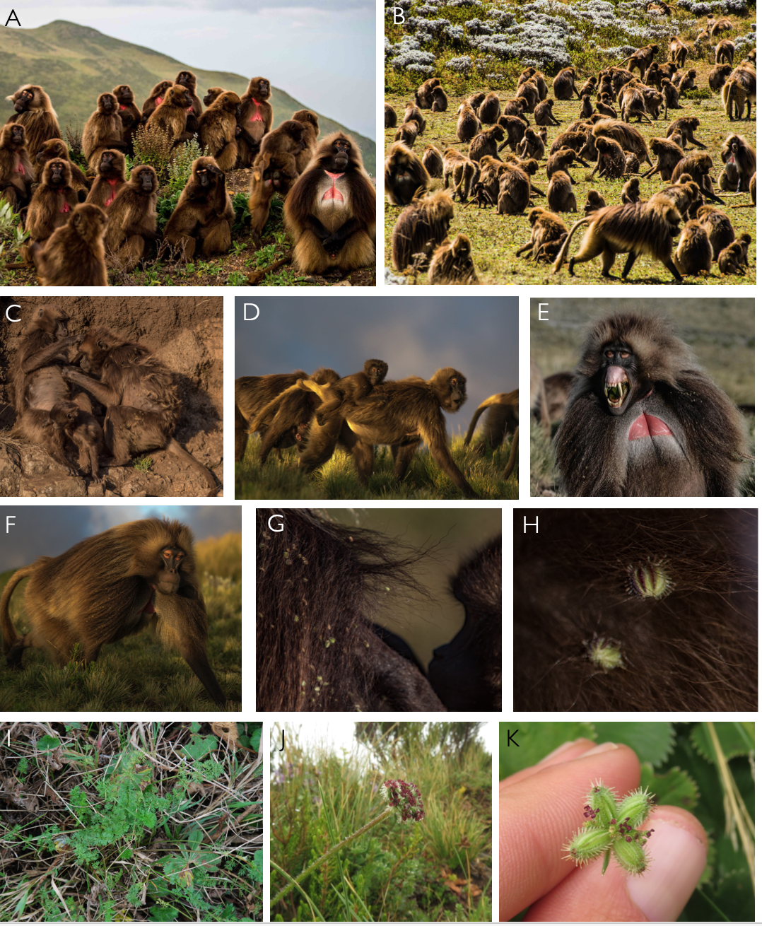

FIGURE 1.

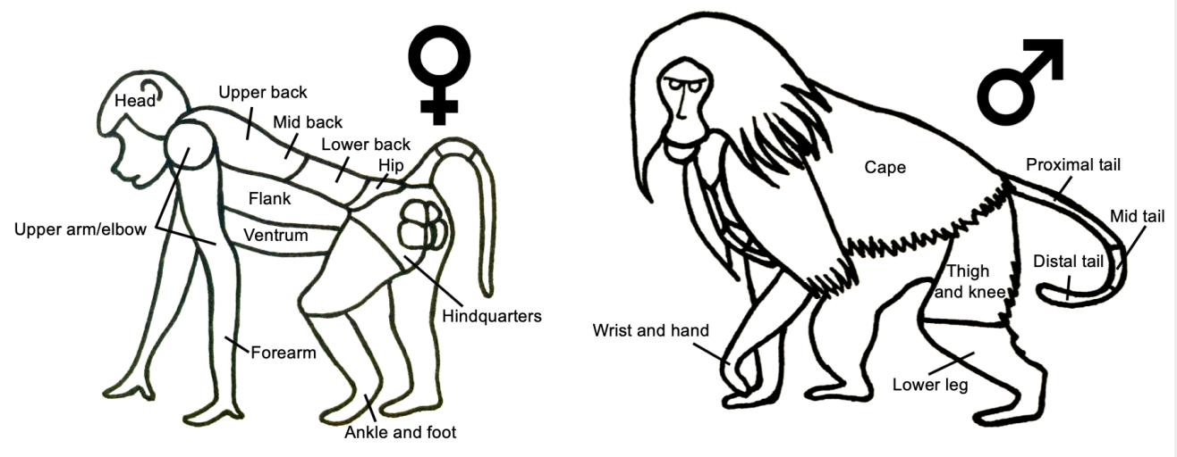

FIGURE 2.

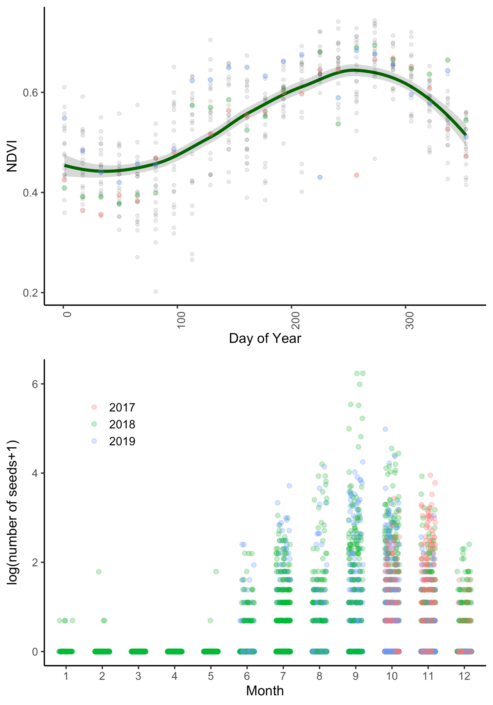

FIGURE 3.

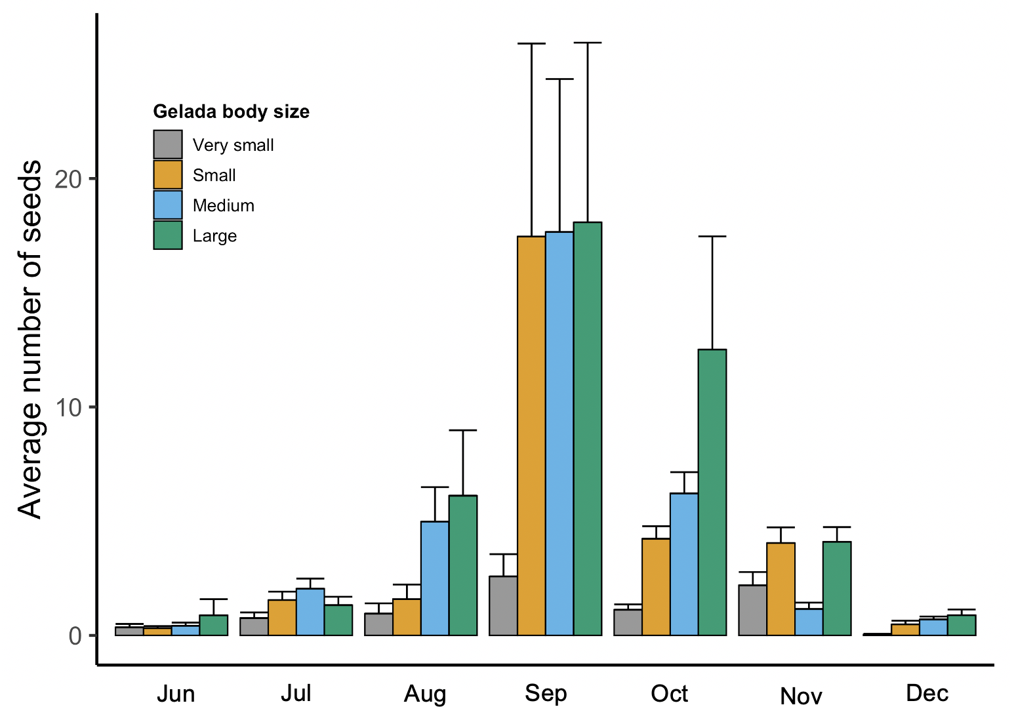

FIGURE 4.

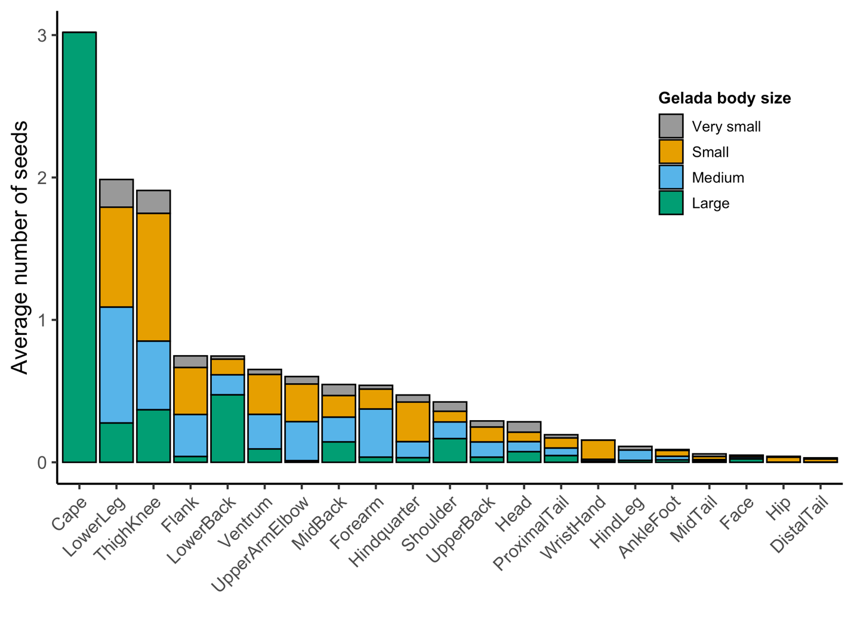

FIGURE 5.

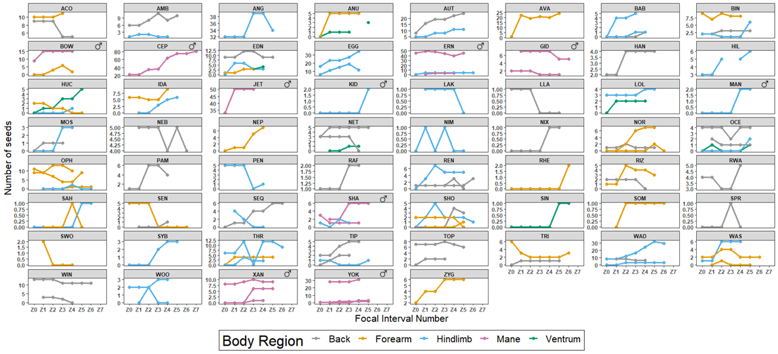

FIGURE 6. suggestion for low vs high seed panels. Re-run with cape.

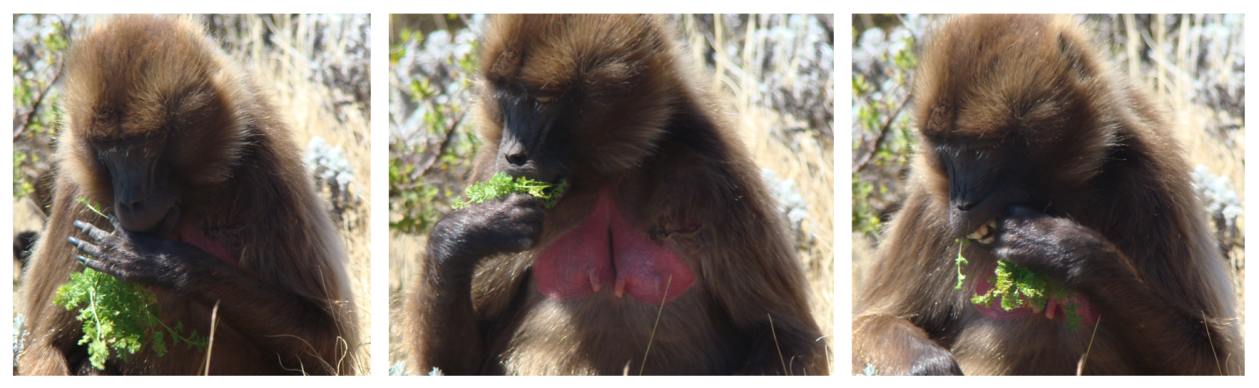

FIGURE S1.

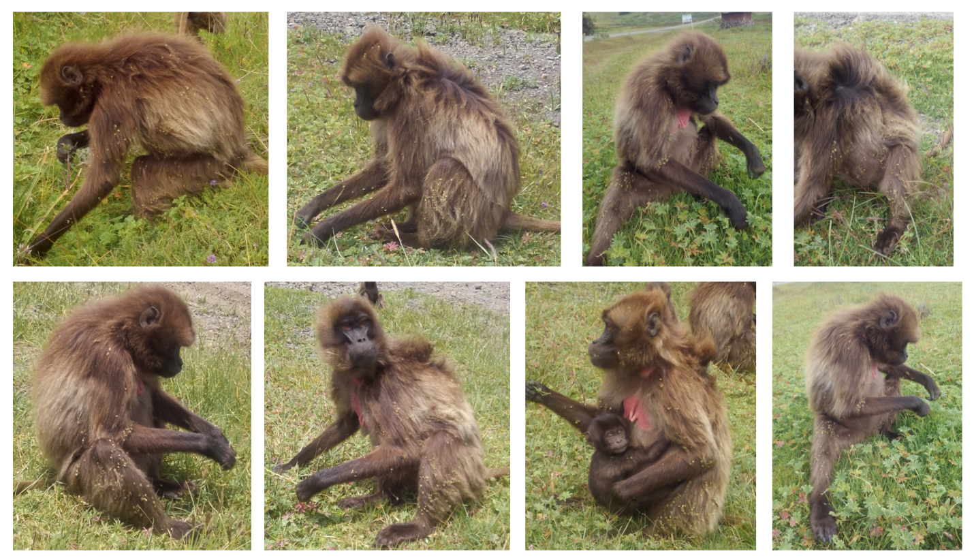

FIGURE S2.